**PF Lab Task 2**

**Section 1 (Deadline: 3 hours)**

Write the **Pseudocodes** and **flowcharts** of the following. You are supposed to submit a single zipped folder named as your roll Number **(23i-xxxx)**. The folder will contain images of all questions.

You must implement an input validation check where necessary.

1. Take input two numbers and calculate the sum
2. Input two numbers and display the result of num1/num2.
3. Input user’s age. Check if age is less than 18 display “child”, if age > 18 print “adult”.
4. Find the Maximum of Three Numbers
5. Find the Average of Three Numbers
6. Input a number. If a number is multiple of seven then display (output) “I love programming”.
7. Calculate & display Simple Interest
   1. simple_interest = (principal * rate * time) / 100
8. Convert Fahrenheit to Celsius
   1. celsius = (fahrenheit - 32) * 5 / 9
9. Calculate Area of a Rectangle
10. Swap Two Numbers
11. Calculate the difference between two points.
    1. distance=sqrt((x2 – x1)² + (y2 – y1)²)
12. Implement the quadratic formula.

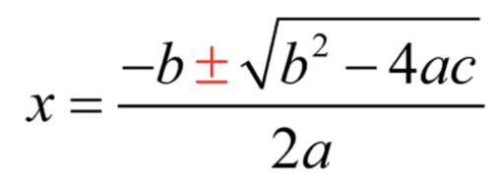

Please note that there will be two values of x.

1. Swap Two Numbers without using a temporary (third) variable.